KOORI KITCHEN

**WEBSITE LAYOUT AND EDITORIAL | FRIDAY, 1 JULY 2022**

**TITLE:** Koori Kitchen

**DESCRIPTION PREVIEW:** Meet the volunteers who cooked up to 2,000 meals a day for NSW flood victims

**WEBPAGE LAYOUT (Webpage layout, copy and visual placements):**

Koori Kitchen

­

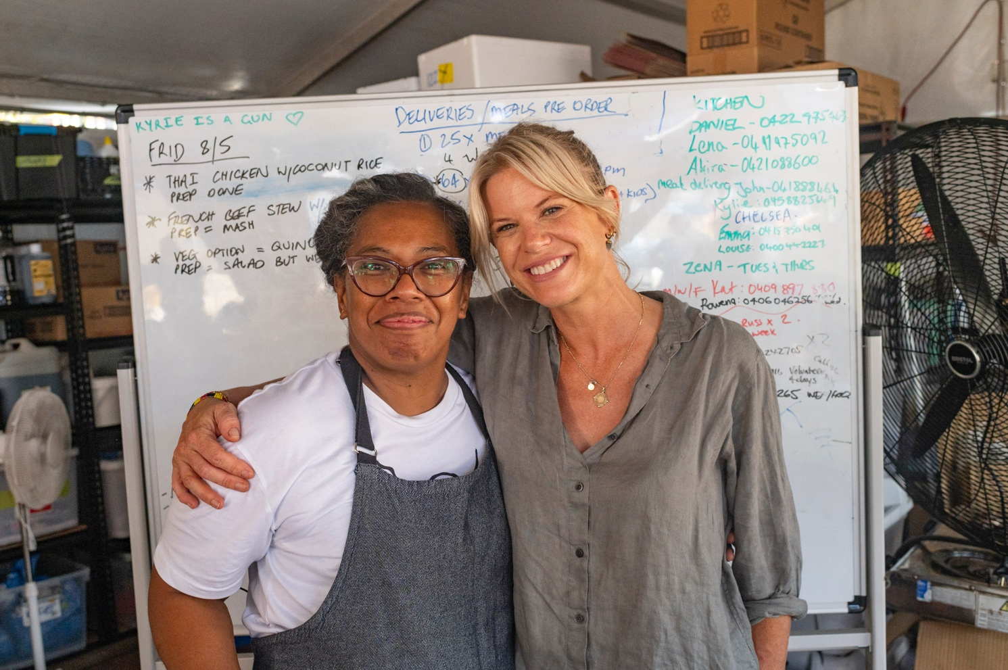

##### Meet the volunteers who cooked up to 2,000 meals a day for NSW flood victims

When chef Izzy Walton heard about the devastating floods in Northern New South Wales, she wanted to do something.

“I know that food brings people together and it can bring a community together, and it's probably the most important thing after any type of disaster,” she said.

“Lismore needed to have some sort of food hub.”In the aftermath of the Lismore floods, Izzy and her friend Chelsea Claydon decided to set up a makeshift kitchen and start cooking meals for the Lismore community.

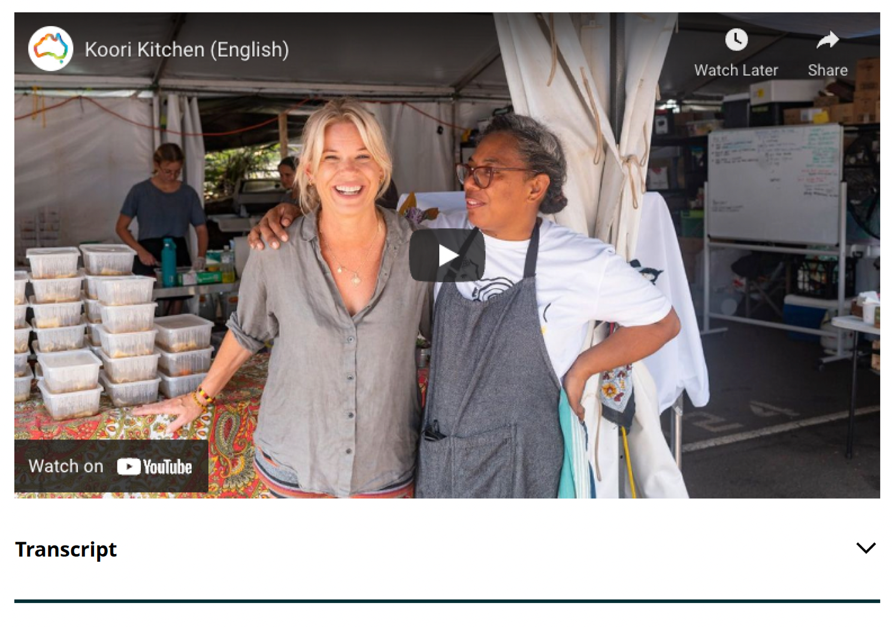

This volunteer group, the ‘Koori Kitchen’, became a symbol of community, compassion and resilience, serving up to 2,000 meals a day for those less fortunate in Lismore.

“What motivated me is being a chef,” Izzy said. “It's been very powerful to be able to be part of that— building the Koori Kitchen – so that people can come and have a hot meal, have a cry, have a laugh. It's been an honour, and a highlight as a chef, to start Koori Kitchen.”

"We’ve been working alongside people that have been without their own homes. They've shown that in these situations people come together and they have compassion and they want to help others, which is quite touching. That's why we do it.” — Izzy Walton

Chelsea said she’s witnessed firsthand the resilience and compassion of not only the Lismore community but the wider Australian community who have come to support them.

“The volunteer community have been absolutely amazing,” said Chelsea. “They've been from all over Australia. We've had trainees coming up from Sydney, Melbourne with all the gear in their car — sleeping in their vans to help. We've had people that are local that have been displaced and actually just need somewhere to keep their minds off things, so they help us in the kitchen and they get so much joy out of it.”

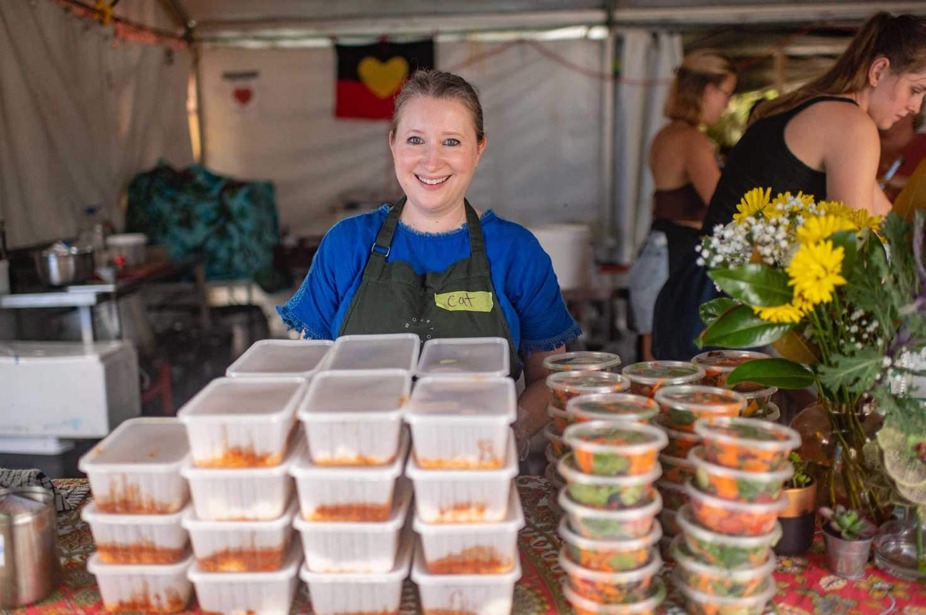

Koori Kitchen volunteers have served up to 2,000 meals a day for Lismore flood victims.

Chelsea shared that her work with Koori Kitchen has had an enormous impact on her life and she now feels part of the Lismore community.  
  
“They've [the Lismore community] become my family, basically. The Koori Mail have been incredibly supportive. We've been working alongside people that have been without their own homes. They've shown that in these situations people come together and they have compassion and they want to help others, which is quite touching. That's why we do it. That's why I come back every day.”

The work done by Izzy, Chelsea and community volunteers through the Koori Kitchen shows us how Australians come together to give a 'fair go' for all and embrace mutual respect, tolerance and compassion for those in need during times of crisis.

[Learn about the Australian values](https://www.australian-values.gov.au/australian-values/)